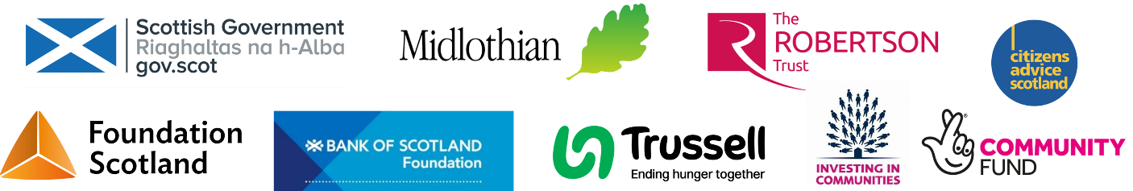


Dalkeith & District
Citizens Advice Bureau
Volunteer
Application
Pack
Welcome!

Thank you for your interest in volunteering with the Citizens Advice Bureau in Dalkeith.

Please read this pack and complete and return the application form at the end. You can post or email it to the address below, or complete it online via the QR code below, or this link www.tinyurl.com/CAB-Volunteer-Pack
Volunteering at the CAB has given me a fantastic opportunity to improve my confidence and develop many transferable skills.

- CAB Volunteer

We may need to photocopy or scan your form, so it is important that it is legible. Please complete it electronically or in black ink.

Please feel free to call the Bureau at any time if you have any questions. For an informal chat, please phone 0131 654 4363 and ask to speak with the Volunteer Manager, or email Volunteer@DalkeithCAB.org.uk.

Please bear in mind, the Bureau is very busy so apologies in advance if we are unable to respond straight away. Many thanks.

Return the form to:

The Volunteer Manager
Dalkeith Citizens Advice Bureau
8 Buccleuch Street
Dalkeith EH22 1HA

E-mail: Volunteer@DalkeithCAB.org.uk

Why volunteer with Dalkeith CAB?

Volunteering for the CAB is a rewarding experience and great opportunity to gain knowledge, experience and skills, while giving something back to the community. It involves:

Meeting new people from a wide range of backgrounds, differing ages and life experiences, with varied outlooks, needs and circumstances.

Gaining new skills and knowledge is a crucial part of volunteering. This can be related to the specific role (e.g. benefits, debt, admin, social media, etc.) Some of these can lead to recognised qualifications. All roles involve developing valuable transferable skills for customer care, effective communication and engaging with people from all walks of life.

Building confidence. Volunteering gives the chance to try something new, interact with others, be part of a team and gain a real sense of achievement that can help with gaining confidence.

Being part of the community by finding out about organisations and activities within the local area.

New challenges. Challenge yourself to do something different while gaining support from colleagues in the team. By setting goals and applying new skills, you may discover talents you didn’t realise you had!

Making an impact. The time and care you give will make a positive difference in local people and communities. The CAB’s holistic, free, impartial, confidential, quality-assured service is a lifeline for many who are isolated, vulnerable and facing challenges.

And, volunteering is fun!
What roles are available?

These are some of the roles often available at Dalkeith CAB. Tell us about your skills, experience and interests and we will try to find the right role for you!

Advisers

They provide face to face, telephone or online advice and information to clients on issues including benefits, debt, home energy savings, employment and housing. Training for the role takes about 3 months.

Administration
I highly recommend volunteering at the CAB. It’s a fantastic way to develop skills and find career and personal inspiration.
- CAB Volunteer

This involves tasks like scanning documents, updating appointment schedules and rotas, data entry, and similar administrative activities.

Reception

Volunteer receptionists answer phones, open and sort emails and post, greet clients and show them to appointments.

Social Policy

The CAB collects information on issues clients bring that may have implications for policy at a national level. Social Policy volunteers record and report such information to Citizens Advice Scotland.

Social Media

This involves raising awareness of the CAB via social media channels.

Trustee Board

Our governing body is made up of volunteers who meet six times per year and carry out other strategic and management functions between times. Visit www.DalkeithCAB.org.uk for more information.
Dalkeith Citizens Advice Bureau
Office Use Only
Date Received
Volunteer Application Form

We strive to be an Equal Opportunities organisation and we welcome applications from all people regardless of age, ethnicity, religion or belief, sex, relationship status, gender identity, disability, sexual orientation or care responsibilities.

We offer free, holistic, impartial, confidential, quality-assured advice. Applicants must be willing to work within these principles, uphold all CAB policies and procedures and implement the CAB Equal Opportunities policy in all aspects of work.

Please note, we do not ask for your age or date of birth, but you have to be over 16 years of age to be a CAB Adviser.

Personal Information
Last Name |  | First Name (s)
Address |  | Known as
Address |  | Phone number
Address |  | Email
Postcode
Please tick this box to  confirm you are over ☐  16 years old |  | How did you hear about the CAB?
Please tick the types of volunteering you are interested in.

Adviser | Administrator | Social Policy
Trustee Board | Reception | Other

(If “other” please explain below.)

Education and Experience
Please tell us about any qualifications or training you’ve completed that you think are relevant to volunteering for Dalkeith CAB. (Please include dates and places.)

Please tell us about your experience (paid and unpaid) and any other skills and knowledge that you feel are relevant to the role of volunteer.

Please use this space to say why you would like to be a CAB volunteer and also provide any further information you wish to support your application.

We need all volunteers to be able to commit up to 6 hours per week – please tick the days and times you would be available.

Day | Monday | Tuesday | Wednesday | Thursday | Friday
Morning
Afternoon

Referees
Please supply the names and contact details for two people who are willing to supply a reference for you, and who have known you for at least 2 years.
Name |  | Name
Job Title/Role |  | Job Title/Role
Address |  | Address
Contact no. and email |  | Contact no. and email
Capacity in which they know you |  | Capacity in which they know you

By submitting this application form to Dalkeith Citizen’s Advice Bureau, you are consenting to the processing and storage of your personal data in order that you can progress through our volunteer recruitment process.

If your application is unsuccessful we will retain your information for 12 months; after this date it will be safely destroyed.

If your application is successful we will retain your information for the duration of your commitment and up to 6 years after you cease volunteering. Please refer to Citizen’s Advice Bureau Privacy Notice for Staff and Volunteers for more information.

I agree to my information being used for the purpose of assessing my suitability to volunteer with Dalkeith Citizen’s Advice Bureau.

Signature |  | Date
Please return this form (by post or via e-mail) to:

The Volunteer Manager
Dalkeith Citizens Advice Bureau
8 Buccleuch Street
Dalkeith
EH22 1HA

Tel (Direct Dial): 0131 654 4363
E-mail: Volunteer@DalkeithCAB.org.uk

Thank you for your interest in volunteering with our CAB.

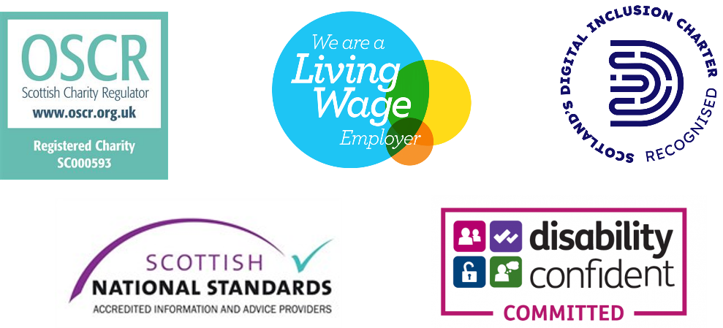

Dalkeith & District Citizens Advice Bureau, 8 Buccleuch Street, Dalkeith, Midlothian EH22 1HA
Tel. 0131 660 1636, Email: bureau@dalkeithcab.org.uk. Web: www.DalkeithCAB.org.uk
Scottish registered charity no. SC 000593. Company Limited by Guarantee in Scotland, no. SC 332676. Authorised and regulated by the Financial Conduct Authority to provide debt advice. FC ref. no. FRN 617446

Dalkeith & District Citizens Advice Bureau, 8 Buccleuch Street, Dalkeith, Midlothian EH22 1HA
Tel. 0131 660 1636, Email: bureau@dalkeithcab.org.uk. Web: www.DalkeithCAB.org.uk
Scottish registered charity no. SC 000593. Company Limited by Guarantee in Scotland, no. SC 332676. Authorised and regulated by the Financial Conduct Authority to provide debt advice. FC ref. no. FRN 617446

Dalkeith & District Citizens Advice Bureau, 8 Buccleuch Street, Dalkeith, Midlothian EH22 1HA
Tel. 0131 660 1636, Email: bureau@dalkeithcab.org.uk. Web: www.DalkeithCAB.org.uk
Scottish registered charity no. SC 000593. Company Limited by Guarantee in Scotland, no. SC 332676. Authorised and regulated by the Financial Conduct Authority to provide debt advice. FC ref. no. FRN 617446

